BCSPA / Dance & Dazzle
School of Arts
Fall Session Begins Sept.9th
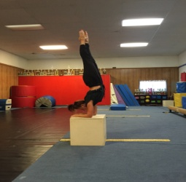
Fall Session
September 9th – December 18th
Jazz, Ballet, Tap, Aerial Acrobatic/Contortion,
Lyrical, Contemporary
Class Schedule
Tuesday Studio A & D
- 4:00-4:30 Private Ariana/ Keiry
- 4:30 -5:30 (7)-10 yr. olds Acrobatics/Ballet/Tap
- 5:30 -6:00 Duet Keiry
- 5:00 -6:00 (4) 5-6 yr. olds Acrobatics/Ballet/Tap
- 6:00 -7:00 10-13 yr. olds Ballet/ Acro/Contortion 6:30-7:30
- 6:15 -7:15 13-Adult Zumba with Alma Kent Studio A or D

Wednesday Studio A
- 4:30-5:00 Private___
- 5:00 -6:00 (10)11-15 yr. olds (Jazz 5:00-5:30)/(Tap 5:30-6:00} Studio A
- 6:00 -7:00 13-19 yr olds Ballet/ Jazz /Contemporary Studio A
- 7:00 -7:30 13-19 yr. olds Acro/Contortion/Conditioning Studio D

Studio A and D
- 5:00- 5:30 Private__________
- 5:30- 6:00 Private__________
- 6:00-6:30 Private__________
- 6:15- 7:15 Zumba with Alma

Additional Private Days/Times Available…Please Contact the Studio.

Tuesday 5:00- 6:00 5-6 yr olds

- McKenzie Webstern
- Abigail Hayword
- Ty Byrd
- Ginny Byrd
- Baylee Hendricks

