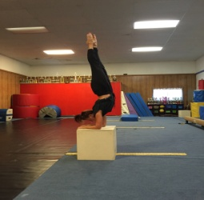
Winter / Spring Session
February 1st – May 28th
Jazz, Ballet, Tap, Aerial Acrobatic/Contortion,
Lyrical, Contemporary
Class Schedule
Monday Studio A
- 5:00 -5:30 Private
- 5:00 -6:00 (10)11-15 yr. olds (Jazz 5:00-5:30)/(Tap 5:30-6:00} Studio A
- 5:30 -6:30 13-19 yr olds Ballet/ Jazz /Contemporary Studio A -2
- 6:30- 7:30 Adults Zumba with Alma Studio A
- 6:30 -7:15 13-19 yr. olds Acro/Contortion/Conditioning Studio A - 2

Tuesday Studio A
- 3:30 / 4:00 Private Available_________________
- 4:15 -5:30 (4) 5-6 yr. olds Acro/Ballet/Tap
- 5:15 -6:15 (7)8-10 yr. olds Acro/Ballet/Tap
- 5:30 – 6:30 11-14 yr. olds Ballet/ Acro/Contortion Studio A
- 6:15 -6:45 Private Arianna/ Keiry
- 6:45 -7:30 Private Couples Dance____________________
- 7:30 – 8:15 Private _________________________
Wednesday Studio A
- 5:00 Private ____________________
- 5:00 -6:00 (10)11-15 yr. olds (Jazz 5:00-5:30)/(Tap 5:30-6:00} Studio A
- 6:00 -7:00 13-19 yr olds Ballet/ Jazz /Contemporary
- 7:00 -7:30 13-19 yr. olds Acro/Contortion/Conditioning Studio D
Thursday Studio A
- 5:00- 5:30 Private__________
- 5:30- 6:00 Private__________
- 6:00-6:30 Private__________

- Additional Private Days/Times Available…Please Contact the Studio.

